PROJECT REPORT

**NATIONAL UNIVERSITY OF MODERN LANGUAGES ISLAMABAD**



Digital Marketing(Project report)

# Premium Hoodies

**Submitted to**

Ms. Saher Andleeb

# Submitted By

Adeel Naeem ,Syed Qasim Ali,Muhammad Khizer Baig,Haris Nawaz (BSAI-(146,161,156,158))

Junaid Asif,Ahtsham Mehmood,Muhammad Asad,Khurram Mushtaq (BSAI-(144,131,153,166))

**Submission Date:** March 15, 2025

PROJECT REPORT

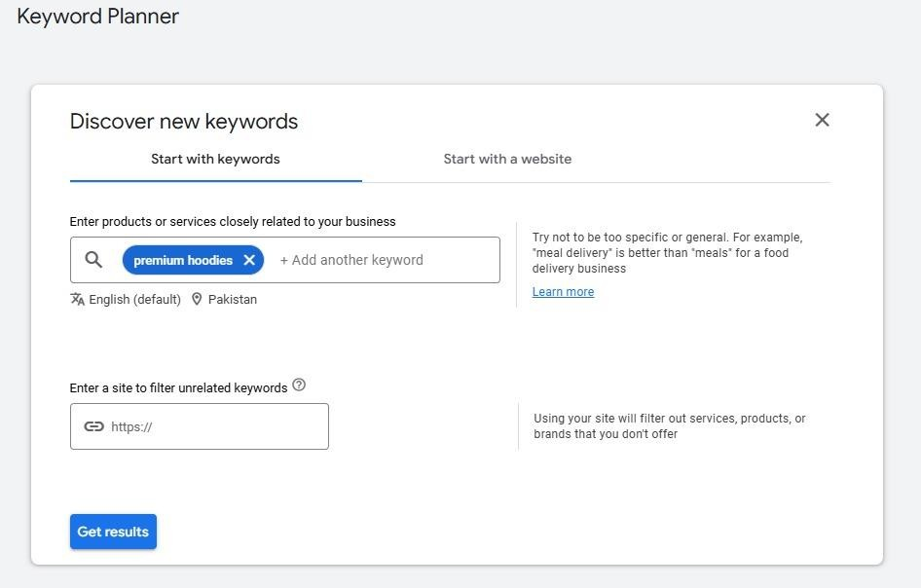**Primary keyword:** Premium Hoodies

**Searching:**

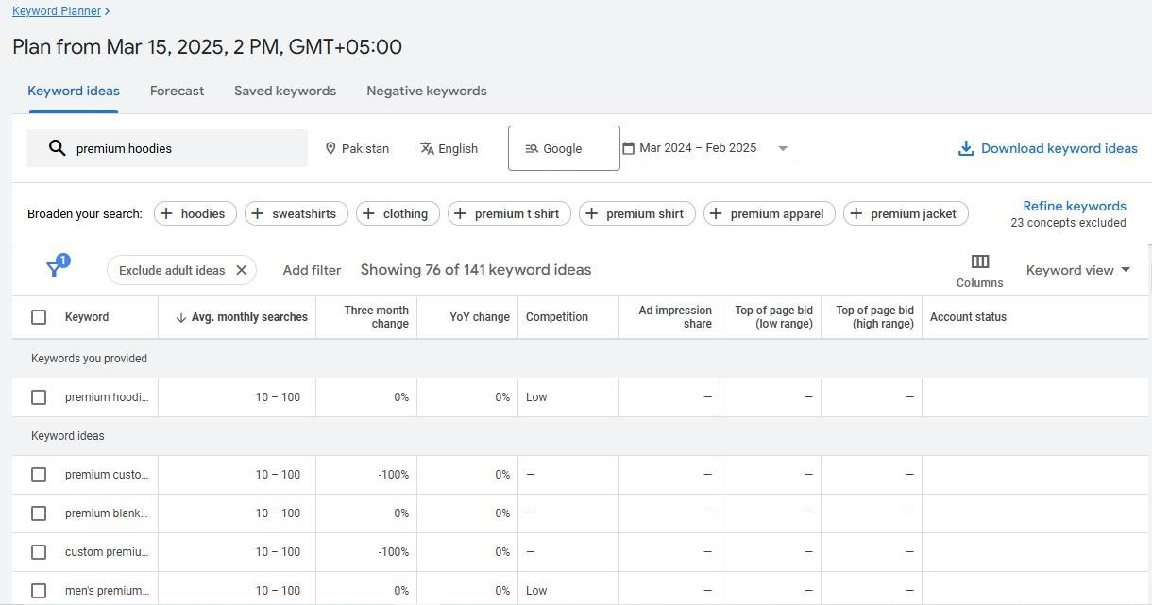

PROJECT REPORT

**Competitors:**

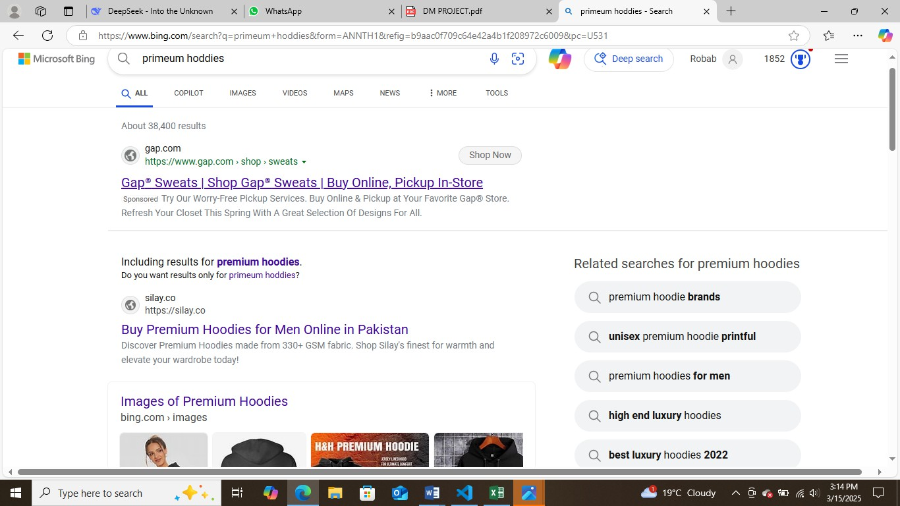

**CSV File:**

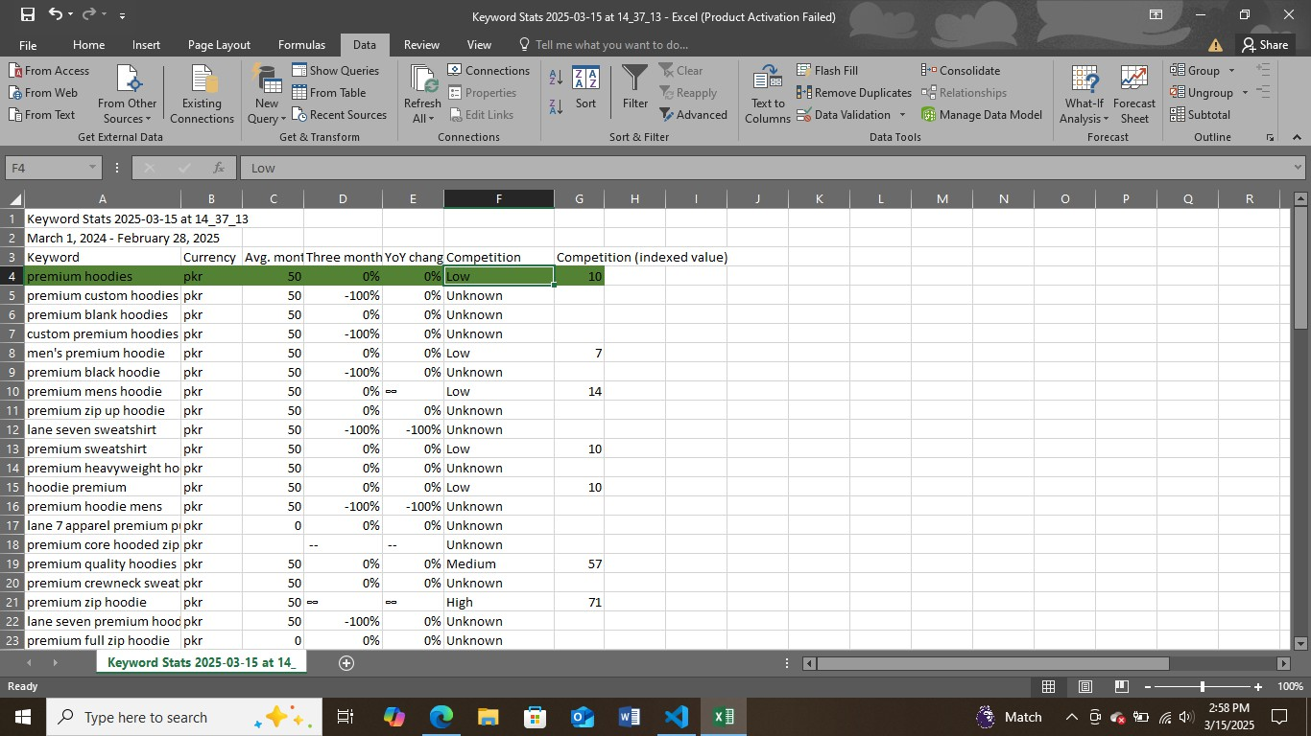

PROJECT REPORT

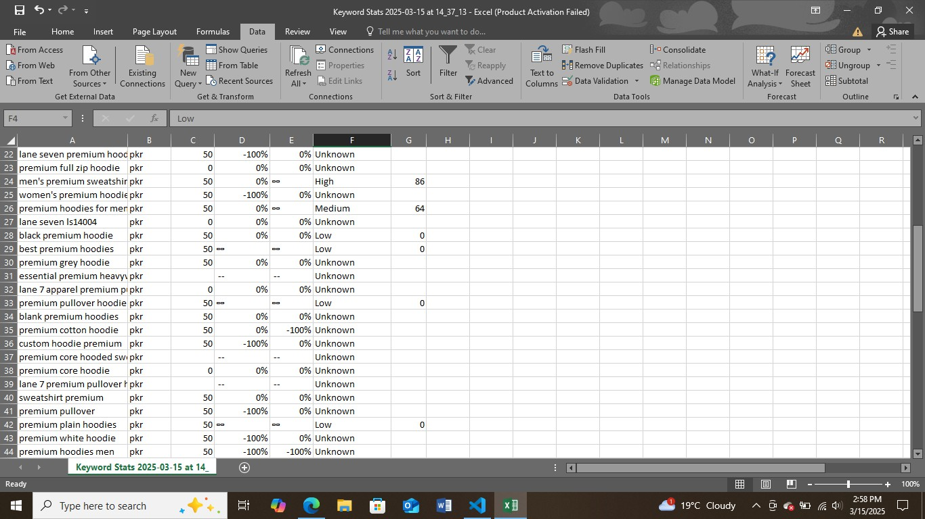

**Final Keywords:**

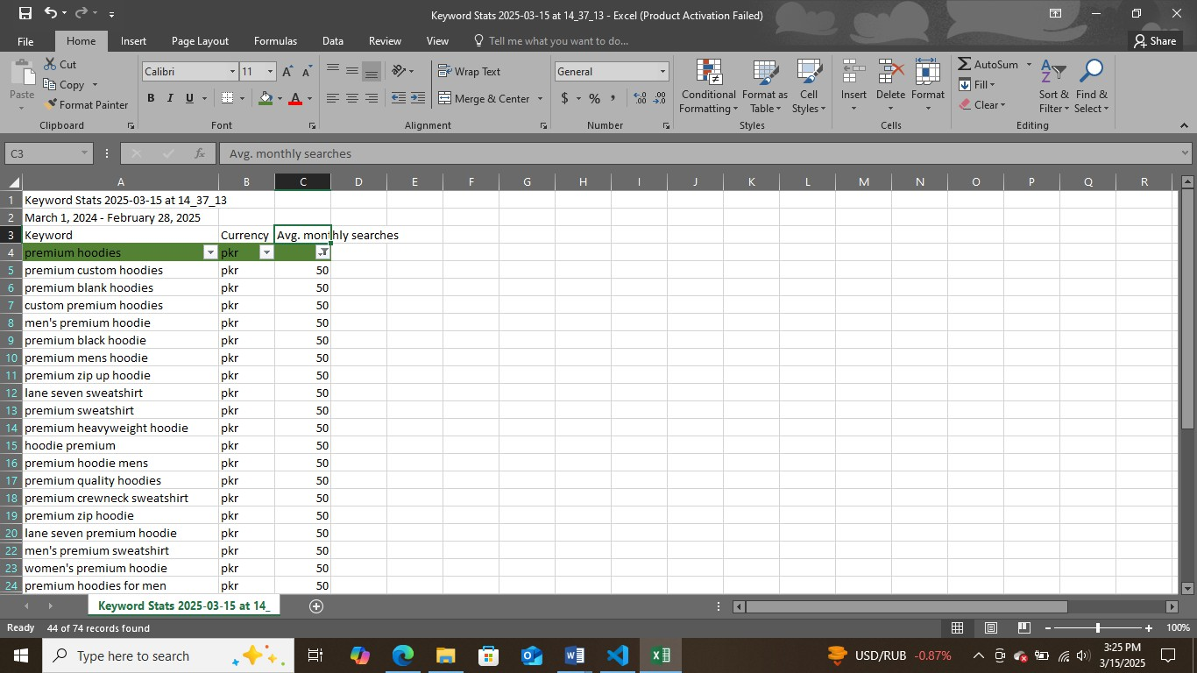

PROJECT REPORT

**Adding Pages**

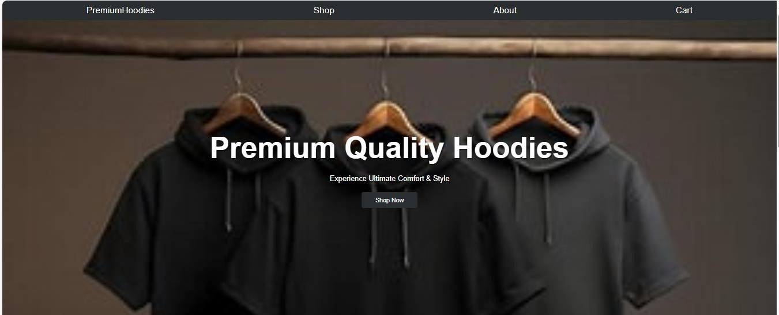**Page1:**

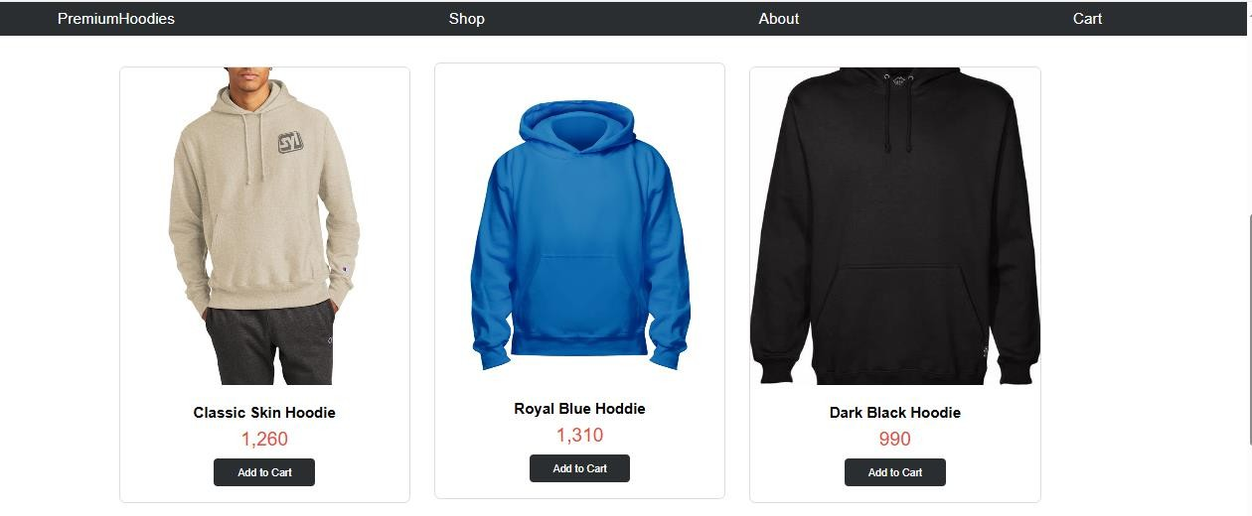**Page2:**

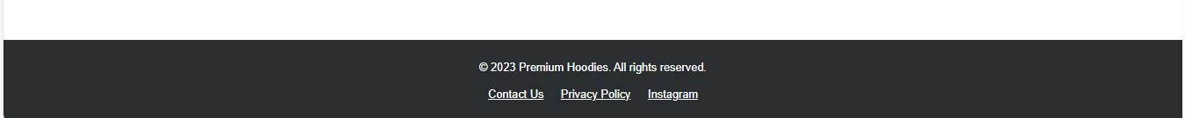**Page3:**

PROJECT REPORT

**On Page SEO**

1. **TITLE TAG OPTIMIZATION:**



1. **KEYWORD OPTIMIZATION IN HEADINGS:**

**C:\Users\Adeel\Pictures\Screenshots\Screenshot (22).png**

1. **IMAGE OPTIMIZATION (ALT TEXT):**

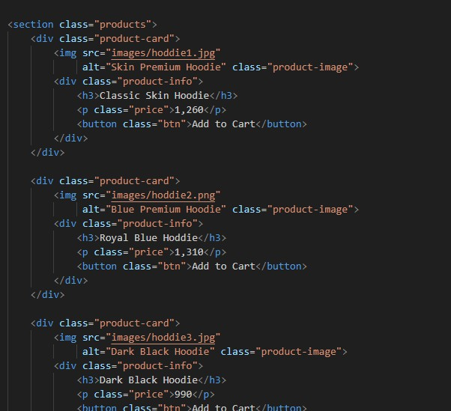

PROJECT REPORT

1. **SOCIAL MEDIA ENGAGE:**

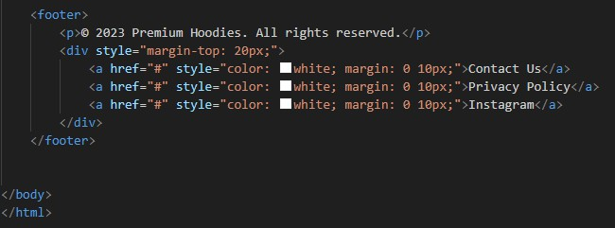

1. **MOBILE-FRIENDLY & FAST LOADING:**

**C:\Users\Adeel\Pictures\Screenshots\Screenshot (25).png**

**The End**